|  |  |  |  |  |
| --- | --- | --- | --- | --- |
|  |  | | |  |
|  | | |
| **H153-381 English General FAQs** | | |
| **Issue** | **01** | |
| **Date** | **2025-01-17** | |
|  | | | | |
|  |  | |  |  |

Contents

1 Modify the IP address of the WAN/LAN port 1

2 Change the login password 3

3 Configure the virtual server 4

4 Configure the NAT function 6

5 Configure the VPN client 7

6 Set the mobile data limit 11

7 Set the Wi-Fi encryption mode of the CPE 13

8 Disable or enable Wi-Fi 14

9 Modify the Wi-Fi name and password 15

10 Configure special applications 16

11 Enable or disable the firewall 18

12 Set the Wi-Fi blocklist and trustlist 19

13 Create an APN list 21

14 Enable or disable the data service 23

# Modify the IP address of the WAN/LAN port

The IP address of the WAN port is automatically obtained from the upstream network and cannot be changed, except for the static IP mode, which needs to obtain the IP address from the carrier. The IP address of the LAN port can be changed as follows:

1. Connect your computer to the CPE's Wi-Fi (or to the CPE's LAN port using an Ethernet cable). Enter 192.168.8.1 in the address box of the browser, and enter the login password to access the management page of the CPE.
2. Go to **Advanced** > **Router**> **DHCP**. In the **LAN IP address** field, enter the new IP address, and click **Save**, then click **Confirm** in the pop-up window. To access the web-based management page, enter the new IP address in the address bar of a browser.

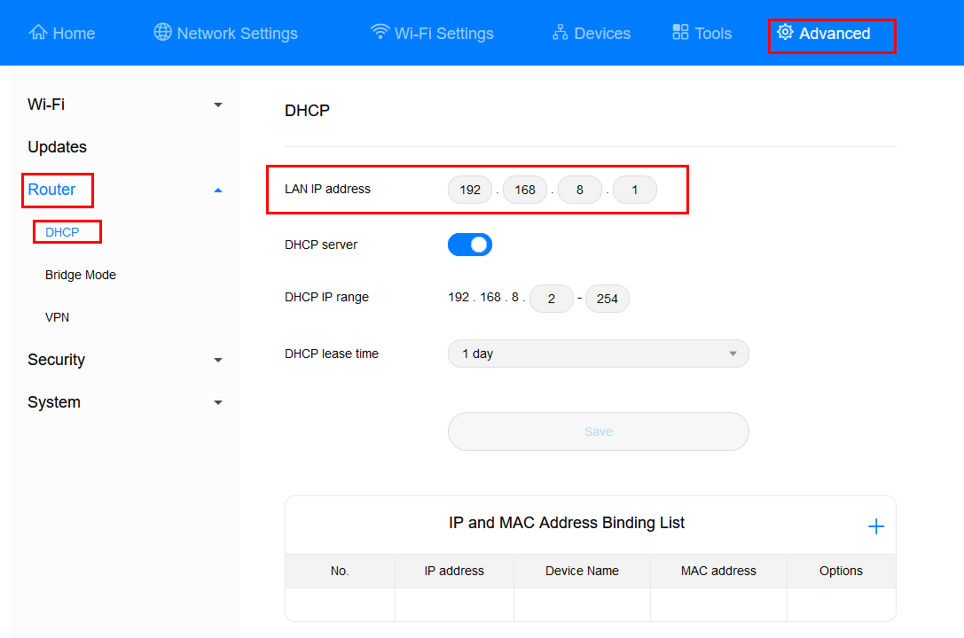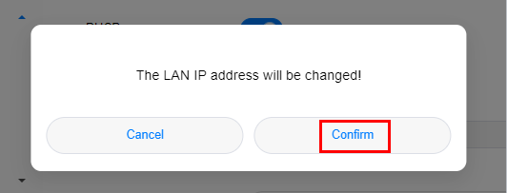

1. To change the network segment of the IP address pool, for example, from 192.168.8.* (* ranges from 2 to 254 by default) to 10.10.10.* (* ranges from 2 to 254 by default), you can directly change **LAN IP address** to 10.10.10.1. In this case, the **DHCP IP range** is automatically changed to 10.10.10.2–10.10.10.254.

If you only want to change the value range of * in 192.168.8.*, you can directly change the start and end IP addresses in **DHCP IP range**.

# Change the login password

1. Connect your computer to the CPE's Wi-Fi (or to the CPE's LAN port using an Ethernet cable). Enter **192.168.8.1** in the address box of the browser, and enter the login password to access the management page of the CPE.
2. Go to **Advanced** > **System** > **Modify Password**, enter the **Current password**, **New password**, and **Confirm password**, and click **Save**.

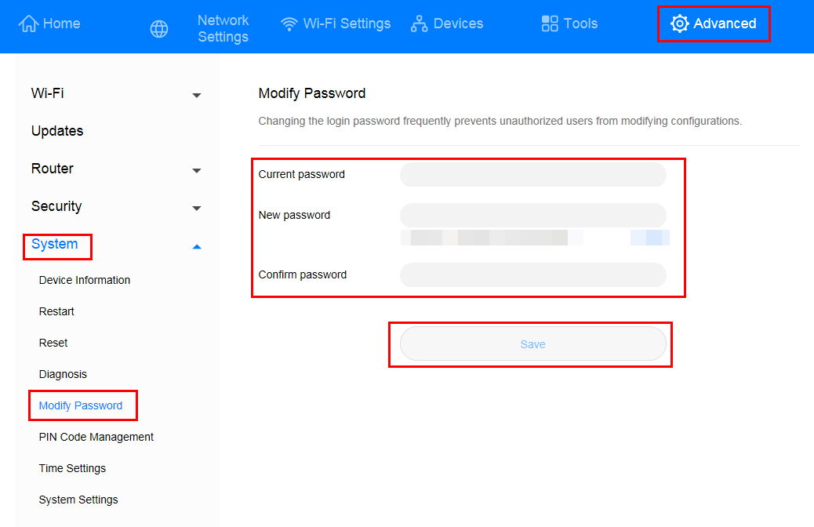

# Configure the virtual server

1. Connect your computer to the CPE's Wi-Fi (or to the CPE's LAN port using an Ethernet cable). Enter **192.168.8.1** in the address box of the browser, and enter the login password to access the management page of the CPE.
2. Go to **Advanced**> **Security** > **Virtual Server**, and click the **+** icon to access the virtual server configuration page.

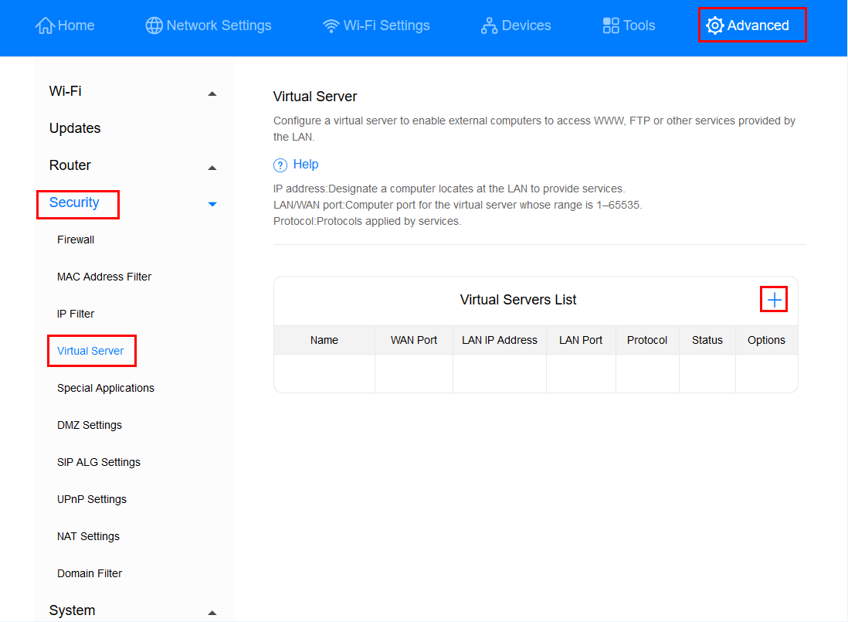

1. Enter **Name**, **Protocol**, **Remote host**, **WAN Port**, **Device**, **LAN IP Address**, and **LAN Port**, and click **Confirm** to complete configuration.

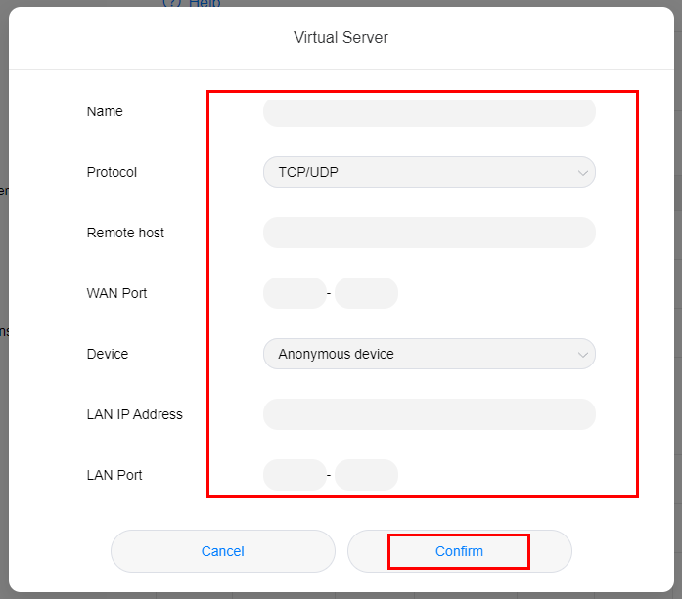

A maximum of 32 virtual servers can be configured.

# Configure the NAT function

NAT is a process in which the source and destination IP addresses of an IP packet are changed when the IP packet passes through a router or firewall. The purpose of this process is to translate internal (private) IP addresses into external (public) IP addresses to prevent IP address exhaustion. The CPE supports port-restricted cone NAT and symmetric NAT. You can set NAT parameters as required.

1. Connect your computer to the CPE's Wi-Fi (or to the CPE's LAN port using an Ethernet cable). Enter **192.168.8.1** in the address box of the browser, and enter the login password to access the management page of the CPE.
2. Go to **Advanced** > **Security** > **NAT Settings**, and select **Symmetric** or **Cone**.

# Configure the VPN client

A virtual private network (VPN) is an enterprise network established on the public network. The enterprise network has the same security, management, and functions as the private network. It can be considered as a virtual private line of an enterprise. For example, a user can connect to the intranet of the enterprise through the VPN network in another area, and the data will be encrypted.

Prerequisites

1. Apply for an available VPN account. For details about the VPN account, contact the VPN service provider.
2. The CPE dials up successfully and can access the Internet.

Method 1: Configuring the L2TP VPN client

1. Connect your computer or phone to the CPE's Wi-Fi (or connect your computer to the CPE's LAN port using an Ethernet cable). Enter **192.168.8.1** in the address box of the browser, and enter the login password to access the management page of the CPE.
2. Go to **Advanced** > **Router** > **VPN**.
3. Click **Enable VPN** to enable the VPN function of the router, and set **Connection type** to **L2TP VPN client**.



The parameter values in the following figure are for reference only. Set the parameters based on the actual VPN account.

When L2TP is used for VPN dial-up, the entered parameters must be the VPN server parameters of the L2TP type. Otherwise, the dial-up will fail.

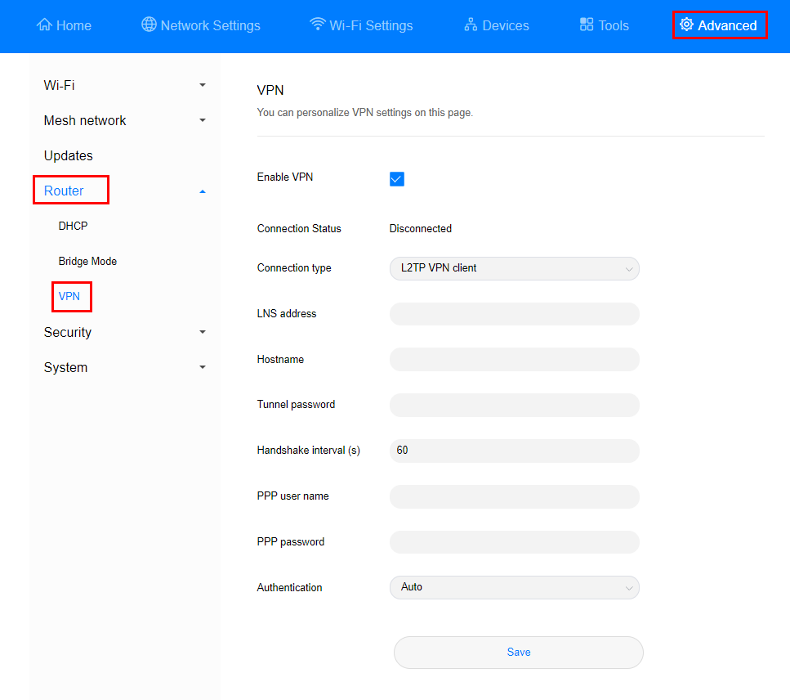

| Option | Description | Mandatory or Optional |
| --- | --- | --- |
| **LNS address** | IP address or domain name of the L2TP server | Mandatory |
| **Hostname** | Host name of the L2TP server  NOTE  If the server does not have a host name, enter any value. If the server requires host name verification, the entered host name must be correct. For details, see the VPN account that has been applied for. | Mandatory |
| **Tunnel password** | Tunnel password of the L2TP server  NOTE  If the server does not have a tunnel password, enter any value. If the server requires tunnel password verification, the entered tunnel password must be correct. For details, see the VPN account that has been applied for. | Mandatory |
| **PPP user name** | User name of the L2TP server | Mandatory |
| **PPP password** | Password of the L2TP server | Mandatory |

1. Click **Save**. If the **Connection Status** is **Connected**, it indicates that the VPN is successfully connected.

Method 2: Configuring the PPTP VPN client

1. Connect your computer or phone to the CPE's Wi-Fi (or connect your computer to the CPE's LAN port using an Ethernet cable). Enter **192.168.8.1** in the address box of the browser, and enter the login password to access the management page of the CPE.
2. Go to **Advanced** > **Router** > **VPN**.
3. Click **Enable VPN** to enable the VPN function of the router, and set **Connection type** to **PPTP VPN client**.



When PPTP is used for VPN dial-up, the entered parameters must be the VPN server parameters of the PPTP type. Otherwise, the dial-up will fail.

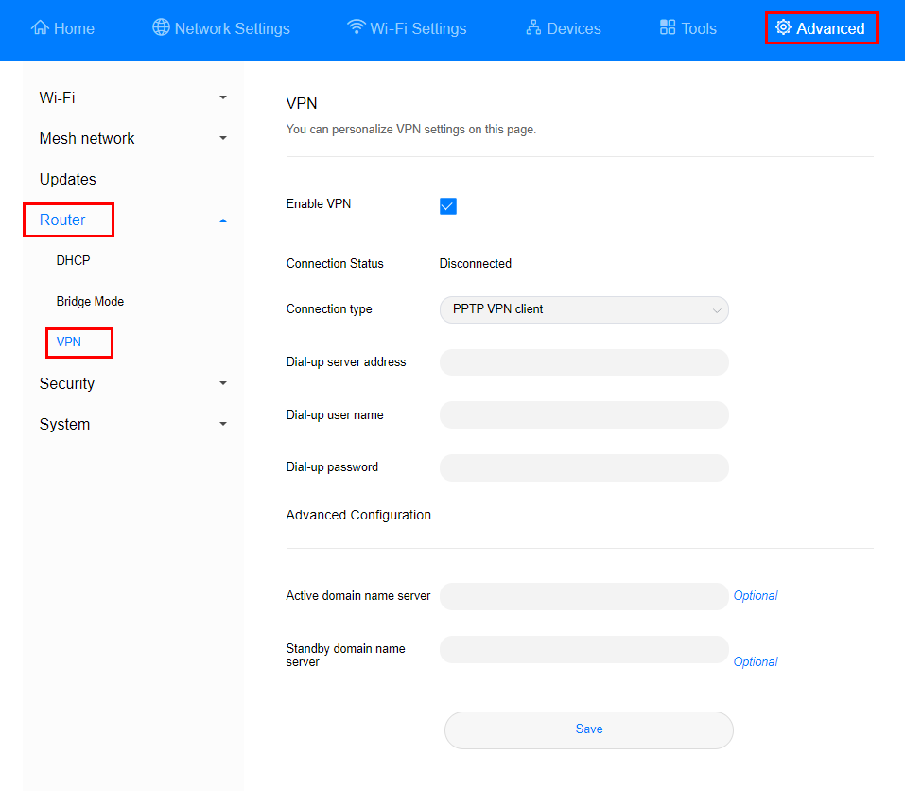

| Option | Description | Mandatory or Optional |
| --- | --- | --- |
| **Dial-up server address** | IP address or domain name of the PPTP server | Mandatory |
| **Dial-up user name** | Dial-up user name of the PPTP server | Mandatory |
| **Dial-up password** | Dial-up password of the PPTP server | Mandatory |
| **Active domain name server** | IP address of the primary DNS server of the PPTP server | Optional |
| **Standby domain name server** | IP address of the standby DNS server of the PPTP server | Optional |

1. Click **Save**. If the **Connection Status** is **Connected**, it indicates that the VPN is successfully connected.

# Set the mobile data limit

1. Connect your computer to the CPE's Wi-Fi (or to the CPE's LAN port using an Ethernet cable). Enter **192.168.8.1** in the address box of the browser, and enter the login password to access the management page of the CPE.
2. Go to **Tools** > **Statistics**, and click.

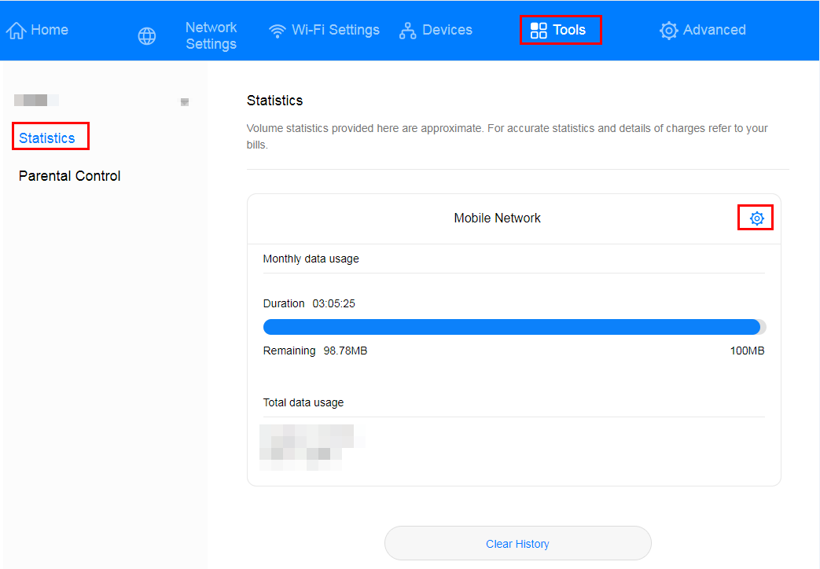

1. Check **Set monthly package**, then set the upper data limit and click **Save**.

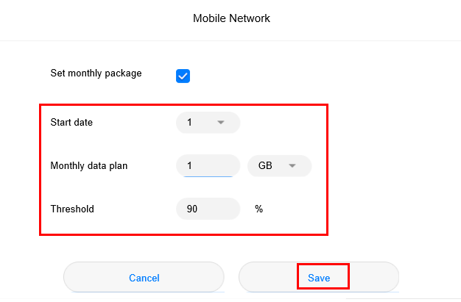

Your device will not disconnect from the Internet after the data usage reaches the limit you set, but will only notify you that the data usage has exceeded the limit. Additional charges may apply if you continue consuming data.

# Set the Wi-Fi encryption mode of the CPE

1. Connect your computer to the CPE's Wi-Fi (or to the CPE's LAN port using an Ethernet cable). Enter **192.168.8.1** in the address box of the browser, and enter the login password to access the management page of the CPE.
2. Go to **Wi-Fi Settings** > **Wi-Fi Basic Settings**, expand the **Security mode** drop-down list box, select the required mode, and click **Save**.

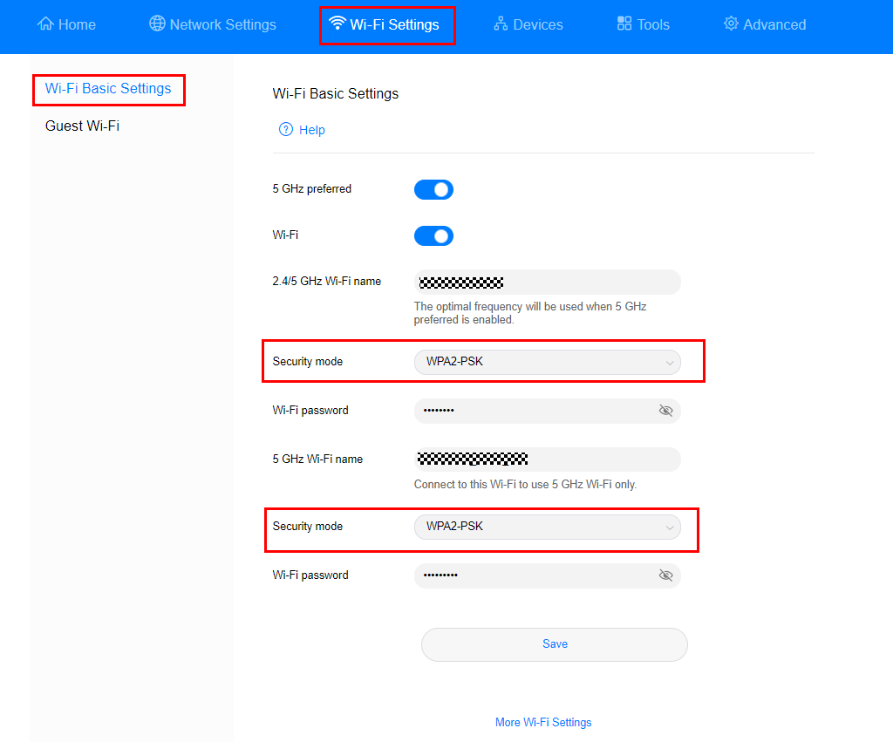

# Disable or enable Wi-Fi

1. Connect your computer to the CPE's Wi-Fi (or to the CPE's LAN port using an Ethernet cable). Enter **192.168.8.1** in the address box of the browser, and enter the login password to access the management page of the CPE.
2. Go to **Wi-Fi Settings** > **Wi-Fi Basic Settings**, Click the **Wi-Fi** switch, then click **OK** in the displayed dialog box to disable Wi-Fi. If the checkbox next to **Wi-Fi** turns blue, it indicates that Wi-Fi is enabled. Wi-Fi is enabled by default.



* To enable Wi-Fi again, connect your computer to the LAN port of the CPE using a network cable, and then log in to the web-based management page to enable Wi-Fi. It is recommended that you keep Wi-Fi enabled.
* After the CPE is restored to factory settings, Wi-Fi is automatically enabled. However, all configuration parameters are cleared after the restoration. In this case, you will need to set the parameters again.

# Modify the Wi-Fi name and password

1. Connect your computer to the CPE's Wi-Fi (or to the CPE's LAN port using an Ethernet cable). Enter **192.168.8.1** in the address box of the browser, and enter the login password to access the management page of the CPE.
2. Go to **Wi-Fi Settings** > **Wi-Fi Basic Settings** to view the current Wi-Fi name and password. Enter the new **Wi-Fi name (SSID)** and **Wi-Fi password**, and click **Save**.

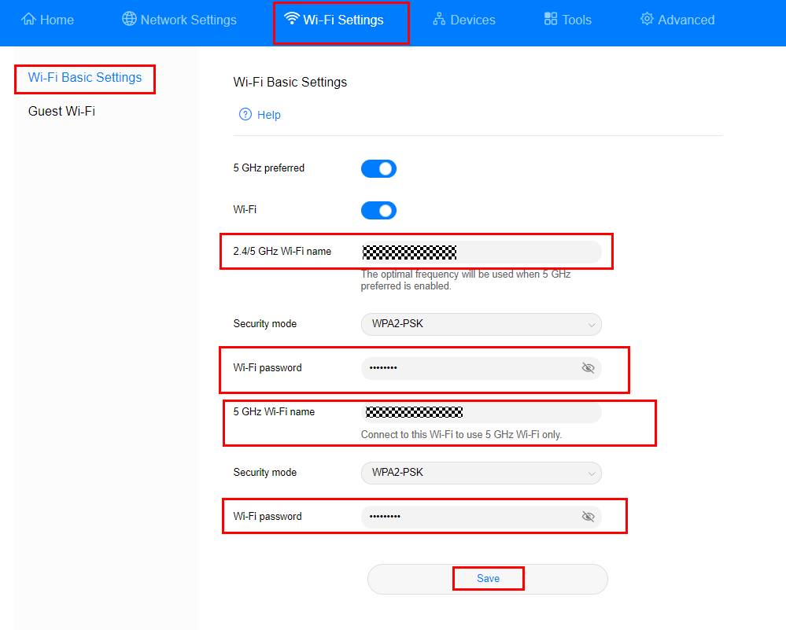

# Configure special applications

Special applications let you use the special features over the LAN such as online games, video calls, and IP calls.

1. Connect your computer to the CPE's Wi-Fi (or to the CPE's LAN port using an Ethernet cable). Enter **192.168.8.1** in the address box of the browser, and enter the login password to access the management page of the CPE.
2. Go to **Advanced** > **Security** > **Special Applications**, click **+** to access the special app configuration page, enter the **Name**, **Trigger Protocol**, **Trigger Port**, **Open Protocol**, and **Open Port**, and click **Save** to complete configuration.

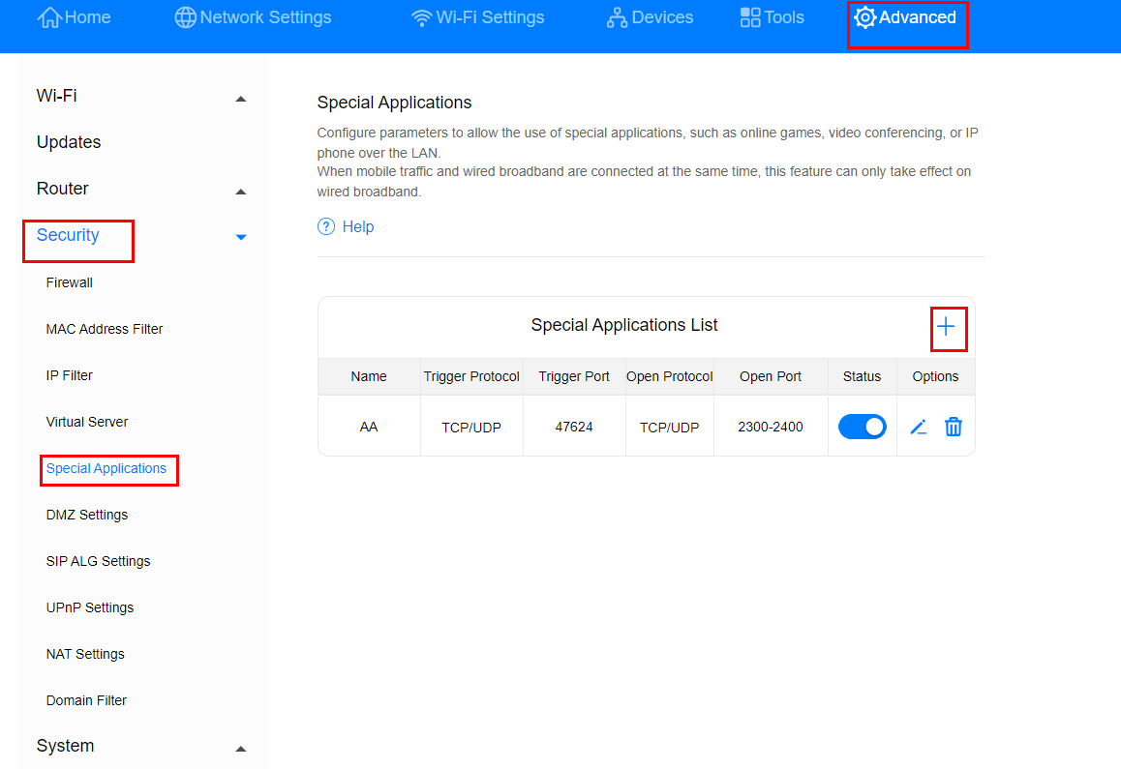

| Option | Description | Mandatory or Optional |
| --- | --- | --- |
| **Name** | Name of the special application to be created | Mandatory |
| **Trigger Protocol** | Type of the protocol used to trigger the application | Mandatory |
| **Trigger Port** | Port number for triggering applications | Mandatory |
| **Open Protocol** | Type of the protocol used by the open port | Mandatory |
| **Open Port** | When the trigger port is detected, the data packets destined for the LAN on this port are allowed to pass through the firewall so that the corresponding special application program can work normally under the NAT route. | Mandatory |



* For details about the parameters, contact the corresponding application provider.
* A maximum of 16 special applications can be configured.

# Enable or disable the firewall

1. Connect your computer to the CPE's Wi-Fi (or to the CPE's LAN port using an Ethernet cable). Enter **192.168.8.1** in the address box of the browser, and enter the login password to access the management page of the CPE.
2. Go to **Advanced** > **Security** > **Firewall** and check **Enable firewall** and click **Save** to enable the firewall function, or uncheck **Enable firewall** and click **Save** to disable the firewall.

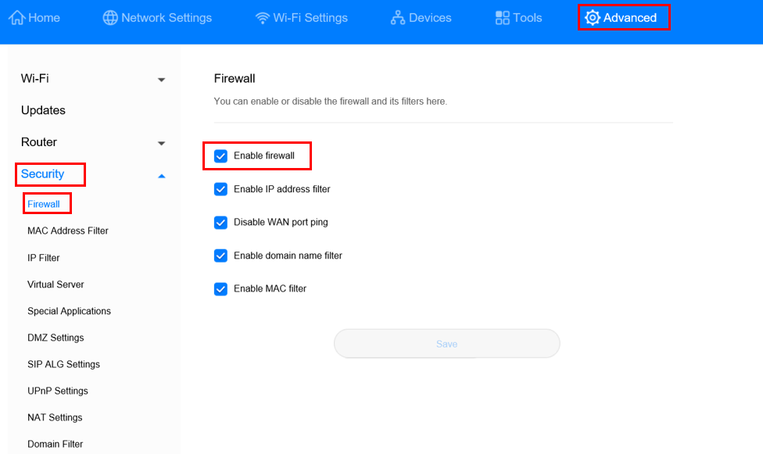

# Set the Wi-Fi blocklist and trustlist

After Wi-Fi access control is enabled, you can set the Wi-Fi of the CPE to blocklist mode or trustlist mode as required. In blocklist mode, devices in the blocklist cannot connect to the CPE. In trustlist mode, only devices in the trustlist can connect to the CPE. Setting the Wi-Fi blocklist and trustlist enhances network security. The CPE can restrict user access even if someone knows your Wi-Fi name and password.

1. Connect your computer to the CPE's Wi-Fi (or to the CPE's LAN port using an Ethernet cable). Enter **192.168.8.1** in the address box of the browser, and enter the login password to access the management page of the CPE.
2. Go to **Advanced** > **Wi-Fi** > **Wi-Fi MAC Filter**. Enable **Wi-Fi MAC Filter**. Set the CPE to blocklist mode (**Block** the access of devices in the list) or trustlist mode (**Allow** the access of devices in the list) as required.
3. Set **Filter mode** to **Block** or **Allow**, and click to add Wi-Fi devices to the Wi-Fi MAC address list. Then click **Save**.

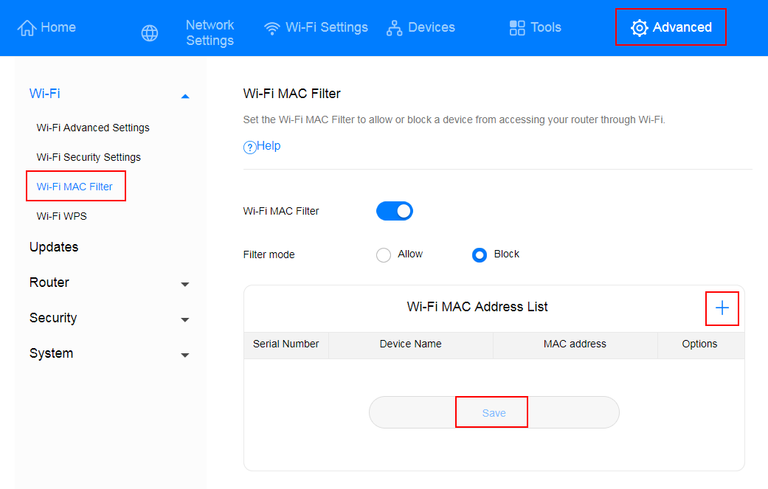

After the devices are added, you can view them in the Wi-Fi MAC address list.

If you do not want to use the blocklist or trustlist function, disable **Wi-Fi MAC Filter**.

# Create an APN list

Create a profile on the management page. After the CPE successfully dials up, it can connect to the Internet in wireless mode.

1. Connect your computer to the CPE's Wi-Fi (or to the CPE's LAN port using an Ethernet cable). Enter **192.168.8.1** in the address box of the browser, and enter the login password to access the management page of the CPE.
2. Go to **Network Settings** > **Mobile Network** > **Internet Connection**, and click **+**.

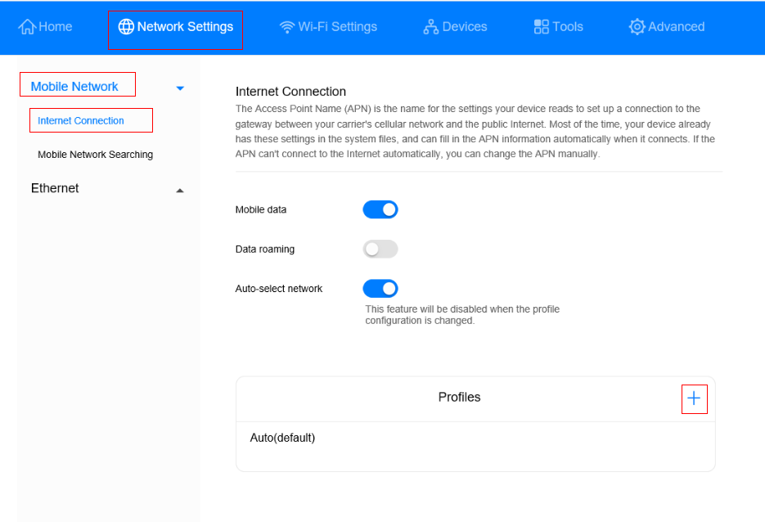

1. Set the following parameters and click **Save**.

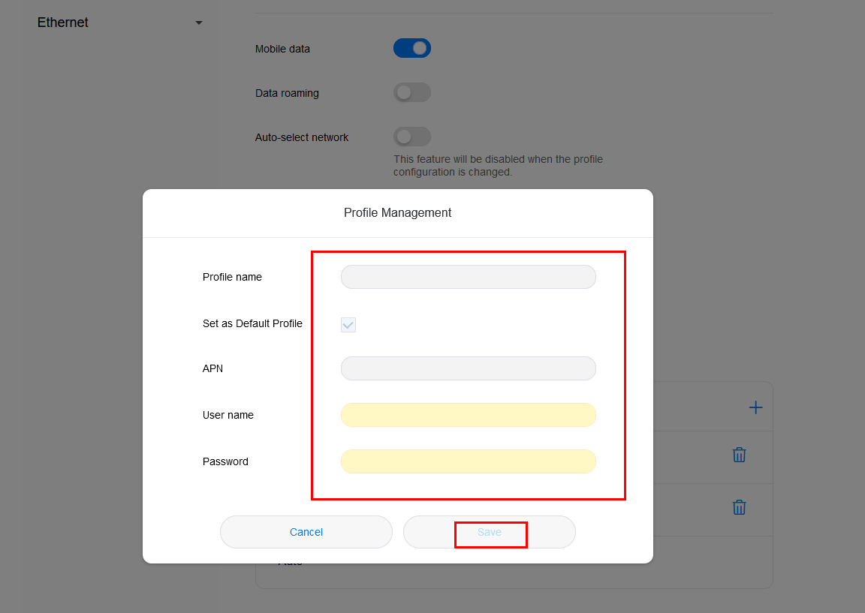

Contact the carrier to obtain the **APN**, **User name**, and **Password**.

# Enable or disable the data service

By default, the data service function is enabled for the CPE. After the CPE registers for the Internet, it automatically initiates a dial-up connection. You can manually disable this function and manually enable it when you need to access the Internet.

1. Connect your computer to the CPE's Wi-Fi (or to the CPE's LAN port using an Ethernet cable). Enter **192.168.8.1** in the address box of the browser, and enter the login password to access the management page of the CPE.
2. Go to **Network Settings** > **Mobile Network** > **Internet Connection**. Disable the **Mobile data** switch to disable the data service. In this case, the CPE will disconnect from the network.

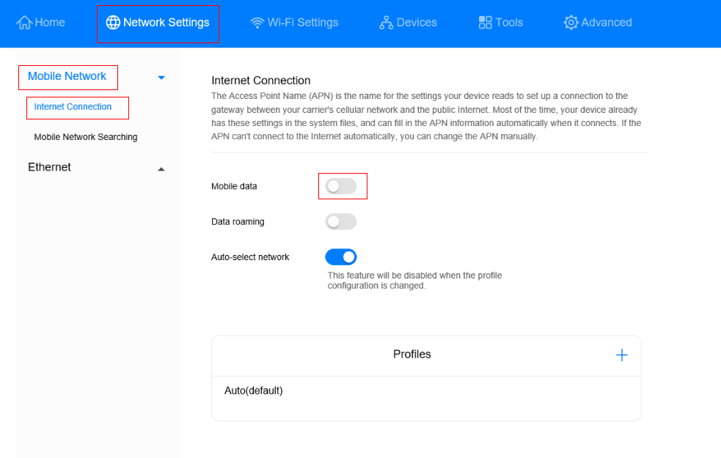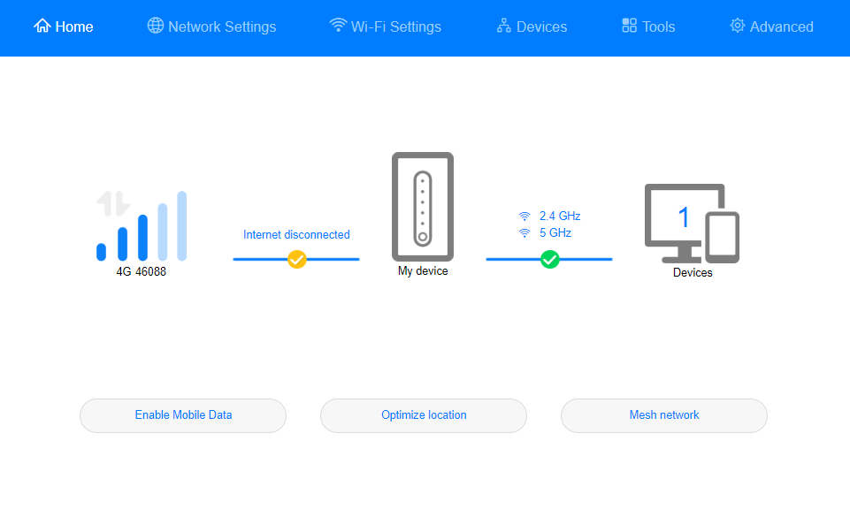

1. When you need to access the Internet, turn on the **Mobile data** switch to enable the data service. The CPE will re-initiate a dial-up connection.

